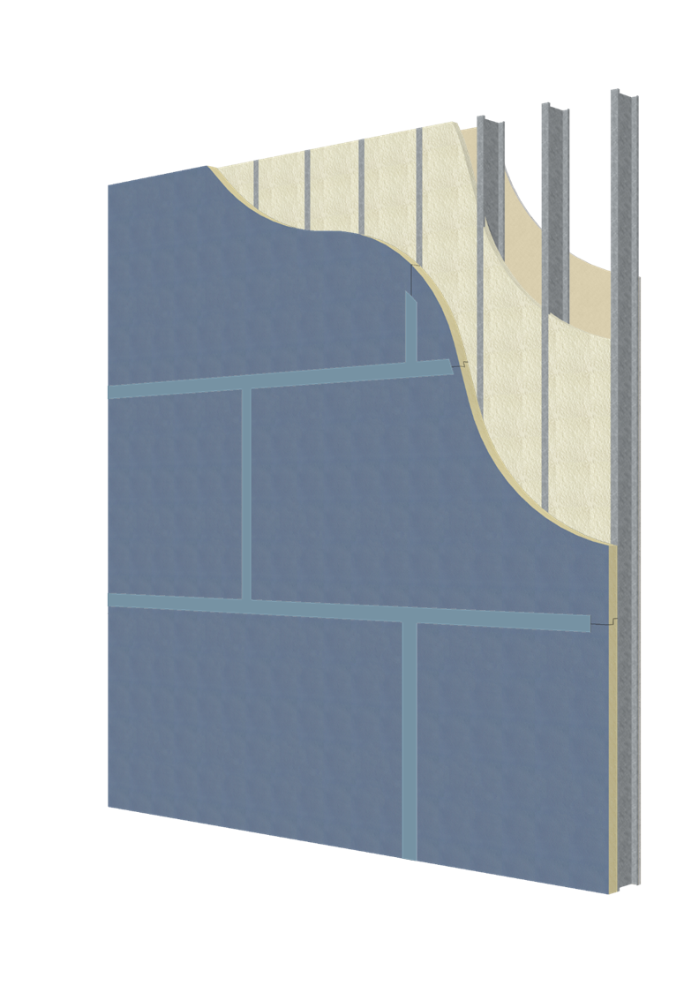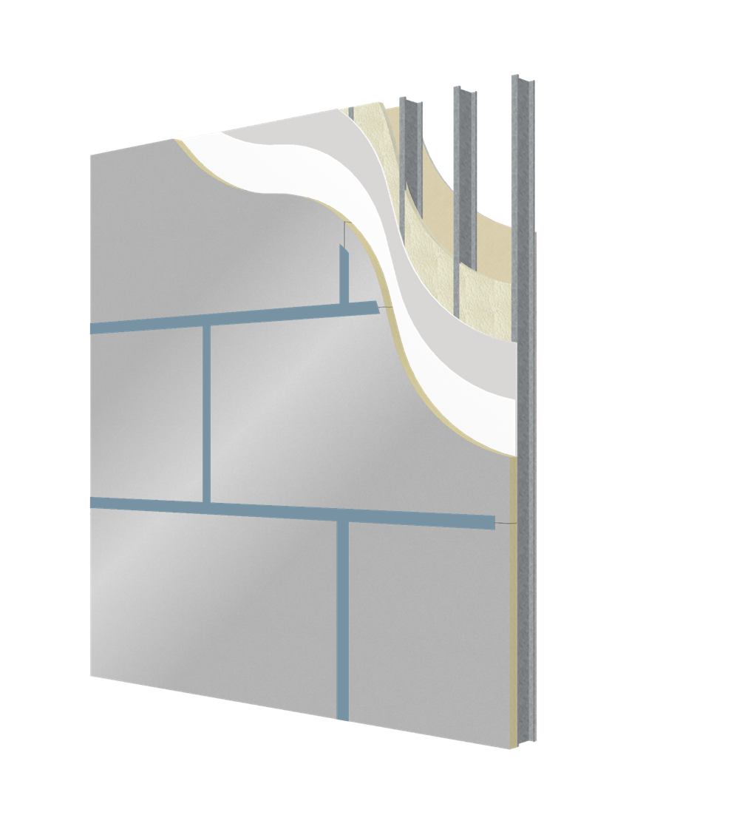

07 2100
DuPont™ Thermax™ Wall System (TWS)
Insulation + Air + Water Barrier Wall System
Guide Specification: Public Bid (Foam on Structure vs Foam on Gypsum)

DISCLAIMER: The manufacturer has reviewed the product information contained in this short form specification. The information is organized and presented to assist the specification writer working on a construction project to select the appropriate products and to save time in writing the project specification Section. The specification writer is responsible for product selection as well as the use and application of this information, and should contact the manufacturer to ensure that all options are available and that the associated specification information is valid and correct.

SPEC NOTE: Insert the required paragraphs into the Section under the noted Articles, and make any required selections. Where selection is indicated with an [OR] statement, select the appropriate paragraph and delete the inappropriate statement. Delete all SPEC NOTEs and [OR] statements prior to final printing.
01 4100: CONTINUOUS ENVELOPE AIR BARRIER
PART 1 GENERAL
1.01 SECTION INCLUDES
A. Administrative and procedural requirements to create an airtight building enclosure that controls infiltration / exfiltration of air.
- The Prime Contractor shall ensure that the continuous air barrier around the building enclosure is achieved with the following characteristics:
  - It must be continuous, with all joints, penetrations, and air paths sealed.
  - It must be structurally supported.
  - It must be connected and continuous between foundation & walls, walls & windows/doors, different wall systems, wall & roof.
1.02 RESPONSIBILITIES
A. Prime Contractor Responsibilities: Unless otherwise indicated, the Prime Contractor shall provide coordination of the trades, and the sequence of construction to ensure continuity of the air barrier system joints, junctures and transitions between materials and assemblies of materials and products, from substructure to walls to roof.
PART 2 – PRODUCTS – [not used]
PART 3 – EXECUTION – [not used]
END OF SECTION

07 2100
THERMAX™ WALL SYSTEM (Public Bid)
PART 1 - GENERAL
1.01 SECTION INCLUDES
A. DuPont™ Thermax™ Wall System*; foil faced polyisocyanurate (ISO) board insulation. Contractor's choice of one of the following wall assembly types: "Foam on foam" or "Foam on sheathing" to complete a continuous thermal, air, and water barrier system.
1. Foam on Structure system; Patented Thermax™ Wall System consisting of rigid insulation, spray foam insulation, and seam treatment to form a continuous thermal, air, and water barrier system.
2. Foam on Gypsum system; System consisting of rigid insulation over air/water barrier, over gypsum sheathing, with spray polyurethane foam insulation in the stud cavity.
1.02 RELATED REQUIREMENTS
A. Section 06 1600 - Sheathing.
B. Section 07 2500 - Weather Barriers: Weather resistant barriers (WRB).
C. Section 07 2627 - Fluid Applied Air Barriers.
D. Section 09 2116 - Gypsum Board Assemblies.
E. [Continue as appropriate for project]
1.03 REFERENCE STANDARDS
A. ASTM C954 - Standard Specification for Steel Drill Screws for the Application of Gypsum Panel Products or Metal Plaster Bases to Steel Studs From 0.033 in. (0.84 mm) to 0.112 in. (2.84 mm) in Thickness; 2015.
B. ASTM C1029 - Standard Specification for Spray-Applied Rigid Cellular Polyurethane Thermal Insulation; 2015.
C. ASTM C1289 - Standard Specification for Faced Rigid Cellular Polyisocyanurate Thermal Insulation Board; 2016.
D. ASTM E84 - Standard Test Method for Surface Burning Characteristics of Building Materials; 2016.
E. ASTM E331 - Standard Test Method for Water Penetration of Exterior Windows, Skylights, Doors, and Curtain Walls by Uniform Static Air Pressure Difference; 2000 (Reapproved 2016).
F. ASTM E2357 - Standard Test Method for Determining Air Leakage of Air Barrier Assemblies; 2011.
G. NFPA 285 - Standard Fire Test Method for Evaluation of Fire Propagation Characteristics of Exterior Non-Load-Bearing Wall Assemblies Containing Combustible Components; 2012.
1.04 SUBMITTALS
A. See Section 01 3000 - Administrative Requirements, for submittal procedures.
B. Product Data: Provide data on product characteristics for each type of product indicated.
C. NFPA 285 Compliance: Submit third party documentation showing wall assembly compliance with NFPA 285.
1.05 QUALITY ASSURANCE
A. Pre-installation Meeting: Prior to commencement of application of wall system, review and document methods and procedures related to installation, including the following:
1. Participants: Authorized representative of the Contractor, Architect, Applicator, and Manufacturer.
2. Review metal wall framing assemblies for potential interference and conflicts and coordinate layout and support provisions for interfacing work.
3. Review insulated sheathing, seam treatment, [and spray polyurethane foam] methods and procedures related to application including manufacturer's installation guidelines.
4. Review construction schedule and confirm availability of products, applicator personnel, equipment, and facilities.
5. Review governing regulatory requirements, and requirements for insurance and certificates as applicable.
6. Review field quality control procedures.
B. Spray Polyurethane Foam (SPF) Installer Qualifications: Company specializing in performing SPF work of the type specified and with at least three years of documented experience and certified by manufacturer.
C. Comply with manufacturer's recommendations for the proper storage and handling of materials.
1.06 MOCK-UP
A. Provide mock-up of specified system, illustrating proper installation of specified wall assembly in compliance with manufacturer's recommendations.
1.07 FIELD CONDITIONS
A. Installation Temperatures: Comply with manufacturer’s recommendations for temperatures during product installation.
1.08 WARRANTY
A. See Section 01 7800 - Closeout Submittals, for additional warranty requirements.
B. DuPont™ Thermax™ Wall System*; Foam on Structure: Register project for Gold System Warranty (20 Yr Thermal, 15 Yr Water Resistance, 6 Mo. Exposure when using DuPont™ Thermax™ XARMOR™ (ci) Exterior Insulation and DuPont™ LiquidArmor™ Flashing and Sealant*).
[OR] Silver System Warranty (20 Yr Thermal, 10 Yr Water Resistance, 6 Mo. Exposure when using DuPont™ Thermax™ (ci) Exterior Insulation* and DuPont™ LiquidArmor™ Flashing and Sealant*).
[OR] Bronze System Warranty (20 Yr Thermal, 5 Yr Water Resistance when using DuPont™ Thermax™ Sheathing* and DuPont™ LiquidArmor™ Flashing and Sealant*).
https://dpscrm.secure.force.com/thermax/
C. DuPont™ Thermax™ Wall System*; Foam on Gypsum: Provide Manufacturer’s Limited Thermal Warranty for polyisocyanurate insulation.

PART 2 - PRODUCTS
2.01 PERFORMANCE REQUIREMENTS
A. Thermal performance:
1. Exterior insulation: ASTM C518, Stabilized R-value of minimum 6.0 per inch with a six month exposure capacity to outdoor elements and 20 year thermal warranty.
a. Code compliance: Class A (<= 25 Flame Spread Index and < 450 Smoke Developed Index) for both core AND finished product classified at max thickness per UL 723 criteria or ASTM E84 criteria.
b. Fire propagation Characteristics: Passes NFPA 285 testing as part of an approved assembly.
2. Interior spray polyurethane foam: ASTM C518, 140 degree F/90 day Aged R-value (measured at 75 degree F mean temperature), for product with a minimum 45 degree F ambient and substrate application temperature is R6.4 per inch and 140 degree F/90 day Aged R-value (measured at 75 degree F mean temperature), for product with a minimum 30 degree F ambient and substrate application temperature is R6.0 per inch.
a. Core density: ASTM D1622, Minimum 2.0 pcf.
b. Acceptable adhesion to substrate based on specific minimum application temperature and proper substrate conditions.
B. Air Barrier: Tested in accordance with ASTM E2357 at pressure of 6.24 psf (300 Pa) or greater, with air infiltration less than 0.04 cfm/sq ft (0.2 L/sq m) of fixed wall area.
1. Conduct testing at positive and negative sustained wind loading of 12.5 psf (0.6 kPa) for one-hour duration in each direction.
2. Provide pressure cycling of wall at 2000 cycles in both positive and negative directions, ending with wind gust loading at 25 psf (1.2 kPa).
C. Water Penetration: Tested in accordance with ASTM E331, with minimum pressure differential of 6.24 psf (300 Pa) for at least two hour test duration without any uncontrolled water penetration.
2.02 DUPONT™ THERMAX™ BRAND- FOAM ON STRUCTURE WALL INSULATION SYSTEM
A. Provide foam on foam wall insulation system that controls thermal, air, vapor, and water penetration, and provides continuity of building envelope enclosure.
1. Provide insulated sheathing on exterior of metal wall framing assembly.
2. Provide joint, penetration and gap sealing material for sealing component joints, penetrations through wall system and gaps between building envelope enclosure components and wall opening frames.
3. Provide spray polyurethane foam (SPF) insulation in stud cavity.
B. Polyisocyanurate (ISO) Board Insulation with Foil Facers on Both Sides: Complies with ASTM C1289, Type I; Class 2 glass fiber reinforced core foam.
1. Basis of Design:
a. DuPont de Nemours Inc.; DuPont™ Thermax™ XARMOR™ (ci) Exterior Insulation*
(4 mil gray facer): building.dupont.com/commercial
2. Flame Spread Index (FSI): Class A - 0 to 25 for both core AND finished product, when tested in accordance with ASTM E84.
3. Smoke Developed Index (SDI): 450 or less for both core AND finished product, when tested in accordance with ASTM E84.
4. Compressive Resistance: At least 25 psi (173 kPa).
5. Water Vapor Permeance: Maximum of 0.04 perms (2.29 ng/Pa sec sq m) per 1 inch (25.4 mm) thickness.
6. Water Absorption: Maximum of 0.1% by volume by total immersion.
7. Board Overall Dimensions: 48 inch (1.22 m) wide by 96 inch (2.44 m) long.
8. Board Thickness: Nominal thickness as indicated on drawings.
a. Edge Treatment: Shiplap edge at long side on 1.5" and greater thicknesses.
9. Front Facer: 4.0 mil gray embossed aluminum
10. Back Facer: 1.25 mil embossed aluminum
11. Thermal Resistance (R-value): Minimum 6 per inch at 75 degrees F (24 degrees C) and minimum 6.6 per inch at 40 degrees F (5 degrees C) in accordance with ASTM C1289
C. Stud Cavity Foam Insulation: Provide two component spray polyurethane foam (SPF) insulation applied to interior face of board insulation wall sheathing and interior studs, complies with ASTM C1029.
1. Assembly, including spray polyurethane foam, must comply with NFPA 285. Refer to requirements in part 1.04.C. of this section.
2. Acceptable Products:
a. BASF; SPRAYTITE 81206.
2.03 DUPONT™ THERMAX™ BRAND - FOAM ON GYPSUM WALL INSULATION SYSTEM
A. Provide foam on sheathing wall insulation system that controls thermal, air, vapor, and water penetration, and provides continuity of building envelope enclosure.
1. Provide insulation board over exterior wall board sheathing, and air and water barrier.
2. Provide joint, penetration and gap sealing material for sealing component joints, penetrations through wall system and gaps between building envelope enclosure components and wall opening frames.
3. Provide spray polyurethane foam (SPF) insulation in stud cavity.
B. Polyisocyanurate (ISO) Board Insulation with Foil Facers on Both Sides: Complies with ASTM C1289, Type I; Class 2 glass fiber reinforced core foam.
1. Basis of Design:
a. DuPont de Nemours Inc.; DuPont™ Thermax™ Sheathing* (1.0 mil smooth facer): building.dupont.com/commercial
2. Other Products:
a. RMax; ECOMAX ci
b. Hunter; Xci Class A
3. Flame Spread Index (FSI): Class A - 0 to 25 for both core AND finished product, when tested in accordance with ASTM E84.
4. Smoke Developed Index (SDI): 450 or less for both core AND finished product, when tested in accordance with ASTM E84.
5. Compressive Resistance: At least 25 psi (173 kPa).
6. Water Vapor Permeance: Maximum of 0.04 perms (2.29 ng/Pa sec sq m) per 1 inch (25.4 mm) thickness.
7. Water Absorption: Maximum of 0.1% by volume by total immersion.
8. Board Overall Dimensions: 48 inch (1.22 m) wide by 96 inch (2.44 m) long.
9. Board Thickness: Nominal thickness as indicated on drawings.
a. Edge Treatment: Square edge at long side.
10. Front Facer: 1.0 mil smooth aluminum
11. Back Facer: 1.0 mil smooth aluminum
12. Thermal Resistance (R-value): Minimum 6 per inch at 75 degrees F (24 degrees C) and minimum 6.6 per inch at 40 degrees F (5 degrees C) in accordance with ASTM C1289
C. Gypsum Sheathing; Provide moisture and mold resistant glass-mat gypsum wallboard products, in accordance with Division 06, Section 06 6100.
D. Weather Resistance Barrier (WRB): Provide moisture and mold resistant barrier over exterior gypsum sheathing in accordance with Section 07 2500.
E. Stud Cavity Foam Insulation: Provide two component spray polyurethane foam (SPF) insulation applied to interior face of board insulation wall sheathing and interior studs, complies with ASTM C1029.
1. Assembly, including spray polyurethane foam, must comply with NFPA 285. Refer to requirements in part 1.04.C. of this section.
2. Acceptable Products:
a. BASF; SPRAYTITE 81206.
2.04 ACCESSORIES
A. Board Insulation Bonding Adhesive: Provide product as recommended by insulation manufacturer that will not damage insulation or substrates.
B. Foam Sealant Penetration Filler: Provide single component spray polyurethane foam (SPF) for sealing wall penetrations through board insulation.
1. Products: DuPont™ Great Stuff Pro™ Gaps and Cracks* single component polyurethane low-pressure sealant or DuPont™ Great Stuff Pro™ Window and Door* single component polyurethane low-pressure foam sealant as manufactured by DuPont de Nemours Inc..
C. Facer Repair Flashing: Provide board insulation manufacturer's recommended flashing for repair of damaged board insulation facer.
1. Products: DuPont™ LiquidArmor™ CM Flashing and Sealant*, DuPont™ LiquidArmor™ QS Flashing and Sealant*, or DuPont™ LiquidArmor™ LT Flashing and Sealant* as manufactured by DuPont de Nemours Inc..
D. Flashing and Sealant: Provide for sealing joints, seams and veneer tie penetrations through board insulation.
1. Spray applied elastomeric liquid flashing and sealant, grey-blue color.
a. Product: DuPont™ LiquidArmor™ CM Flashing and Sealant* as manufactured by DuPont de Nemours Inc..
b. Product: DuPont™ LiquidArmor™ QS Flashing and Sealant* as manufactured by DuPont de Nemours Inc..
2. Trowel applied single component silicone flashing and sealant, gray color.
a. Product: DuPont™ LiquidArmor™ LT Flashing and Sealant* as manufactured by DuPont de Nemours Inc..
3. Joint Flashing Tape: Provide for sealing joints, seams and veneer tie penetrations through board insulation as recommended by manufacturer.
E. Fasteners: Board insulation manufacturer's recommended polymer or other corrosion protected steel screw with washer for fastening insulation sheathing to CMU substrate; ASTM C954.
1. Provide fastener length and size as required for board insulation sheathing thickness.
2. Provide fastener along placement of base flashing as necessary.
3. Product: Grip-Deck Self-Drilling Ceramic Coated Screws by TRUFAST Walls (formerly Rodenhouse, Inc.).
F. Washer: Provide 2 inch (51 mm) diameter plastic washers for each screw fastener.
1. Product: Thermal-Grip ci prong washer by TRUFAST Walls (formerly Rodenhouse, Inc.).
G. Sill Plate Seal: Provide flexible polyethylene foam gasketing strip between top of foundation and sill plate.
1. Product: DuPont™ Styrofoam™ Brand Sill Seal Foam Gasket* as manufactured by DuPont de Nemours Inc..
H. Roof/Wall Juncture Sealing
1. Maintain continuity of air barrier by sealing the roof/wall juncture.
2. Acceptable Products:
a. DuPont de Nemours Inc.; DuPont™ Froth-Pak™ Foam Insulation* (Class A).

PART 3 - EXECUTION
3.01 INSTALLATION, DUPONT™ THERMAX™ BRAND - FOAM ON STRUCTURE WALL INSULATION SYSTEM
A. Comply with foil faced polyisocyanurate (ISO) board insulation and spray polyurethane foam (SPF) manufacturer’s installation instructions and details for applications indicated.
B. Foil Faced Polyisocyanurate (ISO) Board Insulation:
1. Fasten board insulation to exterior face of metal stud wall framing using insulation sheathing and manufacturer’s recommended screw fastener type and length with washers.
2. Install board insulation panels tightly to each other and around openings and penetrations.
3. Install insulation sheathing panels horizontally with embossed aluminum foil facer to exterior side.
a. Use panels having maximum length to minimize number of joints.
b. Locate vertical edge joints parallel to and centered over support framing.
c. Provide additional support framing wherever panel edge joints do not bear against metal stud framing or sill plate.
4. Fasten panels to support framing with fasteners spaced at maximum of 12 inch (305 mm) on center at wall perimeter, and at maximum of 16 inch (406 mm) on center at panel field.
a. Set perimeter fasteners back from edge of insulation panels at least 3/8 inch (9.5 mm).
b. Drive fasteners to bear tight and flush with surface of insulation panel.
c. Maximum of two board joints may be bridged per fastener.
5. Install flashing along perimeter edge joints of insulation panels.
6. Install flashing at wall tie penetrations and other mechanical fastening assemblies of insulation panels.
7. Install facer repair flashing along top edge of base flashing applied to insulation panel, that may also include termination bar, running horizontally along top edge of flashing and lapped over top edge of base.
a. Provide flat strap in framing at termination bar height to allow for proper fastening of termination bar.
3.02 INSTALLATION, DUPONT™ THERMAX™ BRAND - FOAM ON GYPSUM WALL INSULATION SYSTEM
A. Comply with foil faced polyisocyanurate (ISO) board insulation manufacturer’s installation instructions for applications indicated.
1. Do not install polyisocyanurate (ISO) board insulation that has become soiled, wet, or has not been properly protected from exposure to sunlight.
2. Dry fit polyisocyanurate (ISO) board insulation prior to final installation; neatly trim board around conduits, pipes, and other items that will penetrate board insulation.
3.03 INSTALLATION, GENERAL
A. Gypsum Sheathing: Install in accordance with Section 09 2116.
B. Weather Resistance Barrier (WRB): Install in accordance with Section 07 2500.
C. Spray Polyurethane Foam (SPF) Insulation (optional component):
1. Comply with spray polyurethane foam Manufacturer’s installation instructions.
D. Flashing and Sealant:
1. Apply material within application limits of product manufacturer.
2. Do not apply product on surfaces with standing water or frost.
3. Avoid installing on days with a high probability of significant rainfall.
4. Seal gaps greater than 1/4 inch (6.4 mm) in width with penetration filler prior to applying flashing and sealant.
a. If facer on board insulation is damaged, make note of affected area and apply additional spray over damaged area.
b. Replace damaged insulation, or repair facer flaws with appropriate flashing as recommended by insulation panel manufacturer.
5. Apply flashing and sealant to board joints, penetrations and other fenestration openings as required at material required application thickness.
a. Apply flashing 3 inches (76 mm), plus or minus 1 inch (25.4 mm) wide over board insulation joints, with at least 1 inch (25.4 mm) of spray covers each side of joint.
b. Apply flashing over fasteners and washers along board insulation joints.
c. Install façade attachment system after flashing has been applied.
6. Rough Openings: Apply flashing and sealant at least 3 inches (76 mm) onto face of insulation panel sheathing, and completely cover edge of insulation board; also spray at least 3 inch (76 mm) back onto rough opening substrate.
a. It is recommended to cover back onto rough opening at least 1 inch past the interior weatherseal.
7. Board Insulation or Substrate Penetrations: Apply flashing and sealant at least 2 inches (51 mm) onto face of insulation sheathing and at least 2 inches (51 mm) onto penetration or primary flashing substrate.
8. Use wet mil thickness gauge to ensure proper installation thickness.
a. Where consistently below minimum thickness, apply another layer to achieve proper thickness requirements.
9. Visually inspect for any areas missed and trowel on sealant as necessary.
3.04 FIELD QUALITY CONTROL
A. See Section 01 4000 - Quality Requirements, for additional requirements.
B. Submit spray polyurethane foam (SPF) field inspection and test reports for the following:
1. Installer shall complete daily work record and record other required information including results of completed testing.
a. Maintain copies of daily work record on site for routine inspection.
b. Provide copies of daily work record to insulation system manufacturer, Owner or Owner’s Representative upon request.
2. Contractor is responsible for maintaining daily work record of any required testing and inspections.
3. Upon Owner's request, provide site inspections by qualified third party inspector.
a. Include frequency and cost of inspections as designated by Owner.
b. Upon defects being revealed from site inspections, the Contractor shall immediately rectify these defects at their cost.
4. Installer’s daily work record shall verify conformance with manufacturer’s installation instructions, and specified requirements.
3.05 PROTECTION
A. Protect polyisocyanurate rigid foam board insulation from excess moisture, mechanical damage, and exposure to open flame.
B. Promptly Repair damage caused to board insulation in a manner that retains integrity and continuity of insulation and facer materials.
C. Keep polyisocyanurate board insulation dry and above water on jobsite, and cover with tarp until ready for installation.
D. Promptly cover board insulation with cladding; within maximum of 180 days after installation for DuPont™ Thermax™ XARMOR™ Exterior Insulation* and DuPont™ Thermax™ (ci) Exterior Insulation*, and maximum of 90 days for DuPont™ Thermax™ Sheathing*.
END OF SECTION
NOTICE: No freedom from any patent owned by DuPont or others is to be inferred. Because use conditions and applicable laws may differ from one location to another and may change with time, Customer is responsible for determining whether products and the information in this document are appropriate for Customer’s use and for ensuring that Customer’s workplace and disposal practices are in compliance with applicable laws and other government enactments. The product shown in this literature may not be available for sale and/or available in all geographies where DuPont is represented. The claims made may not have been approved for use in all countries or regions. DuPont assumes no obligation or liability for the information in this document. References to “DuPont” or the “Company” mean the DuPont legal entity selling the products to Customer unless otherwise expressly noted. NO EXPRESS WARRANTIES ARE GIVEN EXCEPT FOR ANY APPLICABLE WRITTEN WARRANTIES SPECIFICALLY PROVIDED BY DUPONT. ALL IMPLIED WARRANTIES INCLUDING THOSE OF MERCHANTABILITY AND FITNESS FOR A PARTICULAR PURPOSE ARE EXPRESSLY EXCLUDED.
DuPont™ Styrofoam™ Brand Spray Polyurethane Foam* contains isocyanate, hydrofluorocarbon blowing agent and polyol. Read the instructions and (Material) Safety Data Sheet ((M)SDS) carefully before use. Wear protective clothing (including long sleeves), gloves, goggles and proper respiratory protection. Supplied air or an approved air-purifying respirator equipped with an organic vapor sorbent and a P100 particulate filter is required to maintain exposure levels below ACGIH, OSHA, WEEL or other applicable limits. Provide adequate ventilation. Contents under pressure. Styrofoam™ Brand SPF should be installed by a trained SPF applicator.
CAUTION: When cured, these products are combustible and will burn if exposed to open flame or sparks from high-energy sources. Do not expose to temperatures above 240ºF (116ºC). For more information, consult (Material) Safety Data Sheet ((M)SDS), call DuPont at 1-866-583-2583 or contact your local building inspector. In an emergency, call 1-989-636-4400 in the U.S. or 1-519-339-3711 in Canada.
DuPont™ Great Stuff Pro™ Polyurethane Foam Sealants and Adhesives* contain isocyanate and a flammable blowing agent. Read all instructions and (Material) Safety Data Sheet ((M)SDS), carefully before use. Eliminate all sources of ignition before use. Cover all skin. Wear long sleeves, gloves, and safety glasses or goggles. Not for use in aviation, or food/beverage contact, or as structural support in marine applications. Provide adequate ventilation or wear proper respiratory protection. Contents under pressure. Not to be used for filling closed cavities or voids such as behind walls and under tub surrounds.
CAUTION: When cured, these products are combustible and will burn if exposed to open flame or sparks from high-energy sources. Do not expose to temperatures above 240ºF (116ºC). For more information, consult (Material) Safety Data Sheet ((M)SDS), call DuPont at 1-866-583-2583 or contact your local building inspector. In an emergency, call 1-989-636-4400 in the U.S. or 1-519-339-3711 in Canada.
DuPont Polyurethane Foam Insulation and Sealant*
CAUTION: When cured, these products are combustible and will burn if exposed to open flame or sparks from high-energy sources. Do not expose to temperatures above 240ºF (116ºC). For more information, consult (Material) Safety Data Sheet ((M)SDS), call DuPont at 1-866-583-2583 or contact your local building inspector. In an emergency, call 1-989-636-4400 in the U.S. or 1-519-339-3711 in Canada.
CAUTION: This product is combustible and shall only be used as specified by the local building code with respect to flame spread classification and to the use of a suitable thermal barrier. For more information, consult (Material) Safety Data Sheet ((M)SDS), call DuPont at 1-866-583-2583 or contact your local building inspector. In an emergency, call 1-989-636-4400 in the U.S. or 1-519-339-3711 in Canada.
DuPont™ LiquidArmor™ Flashing and Sealant*
Read the instructions and (Material) Safety Data Sheets ((M)SDS) carefully before use. It is recommended that spray applicators and those working in the spray area wear eye protection. Contact with exposed skin may cause skin discoloration and dryness. Gloves are recommended for prolonged exposures. Ensure adequate ventilation during spray applications.
DuPont™ ThermaxTM Brand Polyisocyanurate Insulation*
CAUTION: This product is combustible and shall only be used as specified by the local building code with respect to flame spread classification and to the use of a suitable thermal barrier. For more information, consult (Material) Safety Data Sheet ((M)SDS), call DuPont at 1-866-583-2583, or contact your local building inspector. In an emergency, call 1-989-636-4400.
DuPont™ StyrofoamTM Extruded Polystyrene Foam Insulation*
CAUTION: This product is combustible. Protect from high heat sources. A protective barrier or thermal barrier may be required as specified in the appropriate building code. For more information, consult (Material) Safety Data Sheet ((M)SDS), call DuPont at 1-866-583-2583 or contact your local building inspector. In an emergency, call 1-989-636-4400 in the U.S. or 1-519-339-3711 in Canada.
WARNING: Rigid foam insulation does not constitute a working walkable surface or qualify as a fall protection product.
Building and/or construction practices unrelated to building materials could greatly affect moisture and the potential for mold formation. No material supplier including DuPont can give assurance that mold will not develop in any specific system.
*A former product of The Dow Chemical Company
DuPont™, the DuPont Oval Logo, and all trademarks and service marks denoted with ™, ℠ or ® are owned by affiliates of DuPont de Nemours, Inc. unless otherwise noted. © 2019 DuPont. All rights reserved.

Form No. 43-D100414-enNA-0619

